SECR2043 OPERATING SYSTEMS

Name | : MUHAMMAD ADAM BIN RAZALI | Marks
Student ID | : A23CS0116
Section | : S03

This lab assessment is designed to test your understanding and skills on some basic concepts and tools related to operating system. Please follow the instructions carefully and submit your answers in this word document and rename the file as os-lab-assessment01-studentname-matricno.docx.

ACTIVITY 1 : | BASIC LINUX COMMANDS

In this activity, you will practice some basic Linux commands that are useful for operating system tasks. For each question, write down the command you used and the output you got in your answer file. If the command does not produce any output, write "No output" instead.

1. | Display your current working directory.
 | Command | Output
2. | List all the files and directories in your home directory, including hidden ones.
 | Command | Output
 |  | 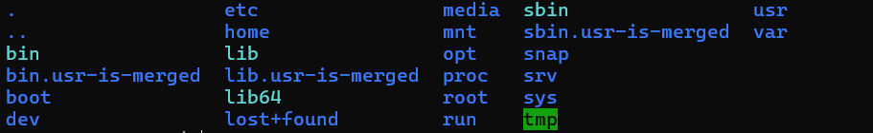
3. | Create a new directory named "os_lab" in your home directory.
 | Command | Output
 |  | NO OUTPUT
4. | Change your current working directory to "os_lab".
 | Command | Output
 |  | NO OUTPUT
5. | Create a new file named "hello.txt" in "os_lab" and write "Hello, world!" in it.
 | Command | Output
 |  | NO OUTPUT

6. | Display the content of "hello.txt".
 | Command | Output
7. | Copy "hello.txt" to another file named "hello_copy.txt" in the same directory.
 | Command | Output
 |  | NO OUTPUT
8. | Rename "hello_copy.txt" to "hello_bak.txt".
 | Command | Output
 |  | NO OUTPUT
9. | Delete "hello.txt".
 | Command | Output
 |  | NO OUTPUT
10. | Display your home directory with additional information, together with subdirectories contents.
 | Command | Output
 |  | 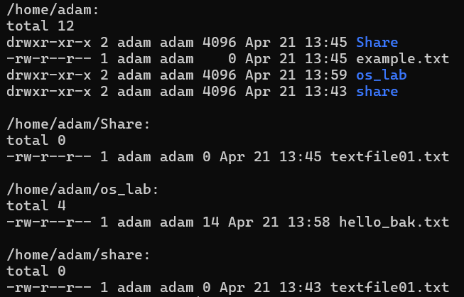
 | Total Mark:

ACTIVITY 2 : | Text File Manipulation

In this activity, you will practice some commands to create and manipulate text files using echo, cat and touch.

For each question, write down the command and the output (if any) in the answer sheet.

1. | Create an empty file named "hello.txt" in the current working directory.
 | Command | Output
 |  | NO OUTPUT
2. | Write the text "Hello World" to "hello.txt" using echo.
 | Command | Output
 |  | NO OUTPUT
3. | Append the text "This is a test" to "hello.txt" using echo.
 | Command | Output
 |  | NO OUTPUT
4. | Display the contents of "hello.txt" using cat.
 | Command | Output
 |  | 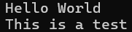
5. | Create another file named "bye.txt" with the text "Goodbye World" using echo.
 | Command | Output
 |  | NO OUTPUT
6. | Concatenate the contents of "hello.txt" and "bye.txt" and display them using cat.
 | Command | Output
 |  | 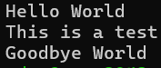
7. | Concatenate the contents of "hello.txt" and "bye.txt" and write them to a new file named "greeting.txt" using cat.
 | Command | Output
 |  | NO OUTPUT

8. | Display the contents of "greeting.txt" using cat.
 | Command | Output
 |  | 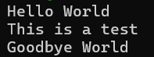
9. | Edit the file "greeting.txt" using Nano and change the word "World" to your name in both lines.
 | Command | Output
 |  | 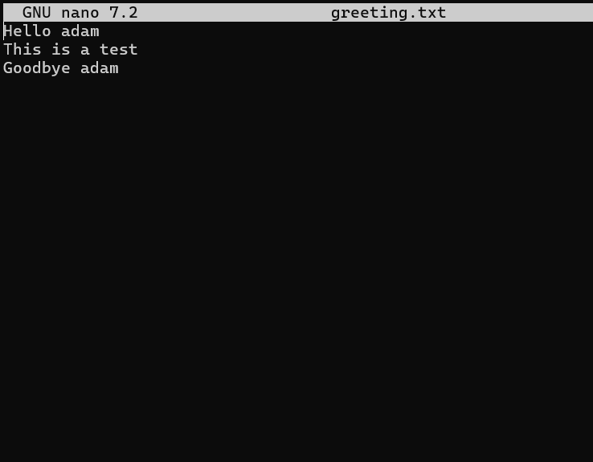
10. | Display the modified contents of "greeting.txt" using cat.
 | Command | Output
 |  | 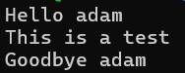
 | Total Mark:

ACTIVITY 3 : | WRITE, COMPILE AND RUN C PROGRAM

In this activity, you will practice how to write, compile and run a simple C program using gcc. For each question, write down the command and the output (if any) in the answer sheet.

1. | Write a C program that prints "Hello World" to the standard output using Nano and save it as "hello.c".
 | Command | Output
 |  | 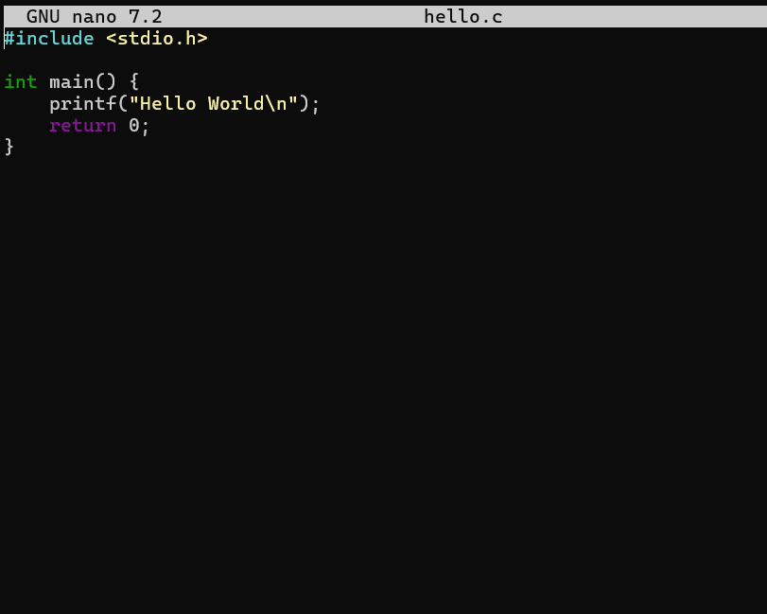
2. | Compile the program "hello.c" using gcc and generate an executable file named "hello".
 | Command | Output
 |  | NO OUTPUT
3. | Run the executable file "hello" and display its output.
 | Command | Output
4. | Write a C program that takes two integers as command line arguments and prints their sum to the standard output using Nano and save it as "sum.c".
 | Command | Output
 |  | 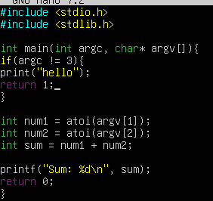
5. | Compile the program "sum.c" using gcc and generate an executable file named "sum".
 | Command | Output
 |  | NO OUTPUT
6. | Run the executable file "sum" with 10 and 20 as arguments and display its output.
 | Command | Output
7. | Run the executable file "sum" with -5 and 15 as arguments and display its output.
 | Command | Output

8. | Write a C program that reads a line of text from the standard input and prints it to the standard output using Nano and save it as "echo.c".
 | Command | Output
 |  | 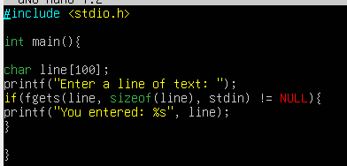
9. | Compile the program "echo.c" using gcc and generate an executable file named "echo".
 | Command | Output
 |  | NO OUTPUT
10. | Run the executable file "echo", type "Hello World" as input and display its output.
 | Command | Output
 |  | 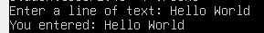
 | Total Mark:

